**Turner Creek Elementary**

**Singing Treefrogs**

*production of*

*Disney’s FROZEN KIDS*

*May 18, 2023*

*6:30 PM*

*TCE Gymnatoriun*

*Our Spring Family Book Fair Night will take place directly before 4 – 6:15 PM*

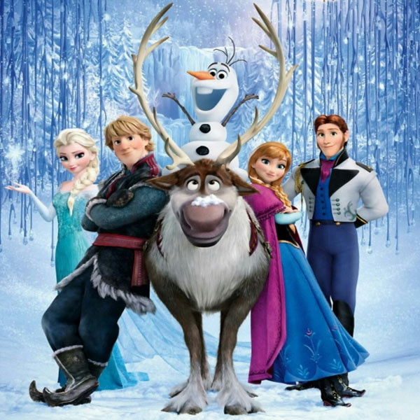

Music & Lyrics by

**Kristen Anderson-Lopez & Robert Lopez**

Book by

**Jennifer Lee**

Based on the Disney film written by Jennifer Lee

and directed by Chris Buck and Jennifer Lee

Disney’s *Frozen KIDS* is presented through special arrangement with, and all authorized materials are supplied by

Music Theatre International, New York, NY

212-541-4684 mtishows.com